Comprehensive Hospitality Data Science Analysis
Integrating Data Cleaning, Forecasting, Segmentation, Sentiment Analysis and Revenue Management in Python
Final Capstone Report | Weeks 1-6

Prepared by: Abhishek Pal
Computer Science Engineering (Data Science), ABES Engineering College
September 2026

Table of Contents
1. Executive Summary
2. Introduction and Project Scope
3. Data and Methodology
4. Module 1 - Data Cleaning and Exploratory Analysis
5. Module 2 - Time Series Forecasting
6. Module 3 - Customer Segmentation
7. Module 4 - Sentiment Analysis
8. Module 5 - Revenue Management and Pricing
9. Analytical Synthesis: Connecting the Five Modules
10. Consolidated Strategic Recommendations
11. Limitations and Critical Reflection
12. Conclusion

1. Executive Summary
This report brings together five weeks of independent analysis into one hospitality data science project, built almost entirely on a single real dataset: the Hotel Booking Demand dataset (Antonio, Almeida & Nunes, 2019; 119,390 bookings, City Hotel and Resort Hotel, 2015-2017), supplemented in the sentiment module by a separate public corpus of 20,491 TripAdvisor hotel reviews. Each module used Python for data preparation, statistical or machine-learning modelling, and visualisation.
Module | Method | Headline result
Cleaning & EDA | pandas data quality audit and exploratory analysis | 119,390 raw rows reduced to 87,221 after removing duplicates, invalid records and outliers; overall cancellation rate 27.53%
Forecasting | SARIMAX with Fourier annual terms vs. Holt-Winters and seasonal-naive baselines | Tuned SARIMAX best on rolling-origin validation (MAE 13.30); all models beat the naive baseline
Segmentation | K-means (validated by Ward hierarchical clustering) on 10 engineered booking features | 3 segments: Families (10.4%, highest ADR and cancellation), Mainstream Leisure (85.8%), Loyal Short-Stay Regulars (3.8%, lowest cancellation)
Sentiment analysis | VADER, TextBlob, clause-level scoring, aspect-based sentiment, TF-IDF + logistic regression | Supervised model (macro-F1 0.712) far outperforms default lexicon tools (macro-F1 0.478); staff and cleanliness are strengths, room condition and noise are weak points
Revenue management | Hedonic OLS pricing model; price-demand elasticity estimation; RevPAR optimisation scenarios | Month effects up to +63% ADR (Aug vs. Jan); naive elasticity regression gives an implausible positive coefficient, correctly diagnosed as reverse causality rather than used for pricing

Beyond the five modules individually, Section 9 shows they agree with and reinforce each other in ways that were not built in by design: the Families segment identified by clustering (Module 3) turns out to be concentrated almost entirely in the same summer peak that the time series model forecasts (Module 2) and that the pricing model prices at a premium (Module 5), and its cancellation rate matches, almost exactly, the cancellation rate of the top ADR quintile found independently in the revenue analysis. This kind of cross-validation across independently built models is, in itself, evidence that the underlying patterns are real rather than artefacts of any one method.

2. Introduction and Project Scope
The hospitality industry generates rich behavioural, textual and transactional data: every booking records who is staying, when, for how long and at what price, and every review records how the stay felt. Used well, this data can inform five connected business questions, which this report addresses as five modules: how much demand should we expect (forecasting), which guests are we actually serving (segmentation), how satisfied are they and why (sentiment analysis), what should we charge (revenue management), and what does the raw data actually look like before any of this is possible (cleaning and EDA, the foundation for everything else).
Scope: this report integrates the four independently developed analyses from Weeks 2-5 (forecasting, segmentation, sentiment, revenue) on top of the Week 1 cleaned dataset, and adds a new synthesis chapter (Section 9) that was not part of any individual week: it deliberately looks for agreement and disagreement between the modules' independent findings, since methodological guidance for this task specifically calls for merging insights rather than presenting them side by side.

3. Data and Methodology
Dataset | Used in | Size | Source
Hotel Booking Demand | Modules 1, 2, 3, 5 | 119,390 bookings (87,221 after cleaning) | Antonio, Almeida & Nunes (2019), via TidyTuesday
TripAdvisor Hotel Reviews | Module 4 | 20,491 reviews | Public TripAdvisor review corpus

The two datasets are not linked by a common guest or hotel identifier, so Module 4's findings describe hospitality sentiment in general rather than the same two hotels analysed elsewhere; this is stated explicitly wherever the modules are connected in Section 9.

3.1 Common tooling
Layer | Libraries
Data handling | pandas, NumPy
Statistics and modelling | statsmodels (OLS, SARIMAX), scikit-learn (K-means, TF-IDF, logistic regression, PCA)
NLP | NLTK (tokenising, POS tagging, lemmatising, VADER), TextBlob, WordCloud
Visualisation | matplotlib, seaborn
Reporting | Results and charts assembled into Word (.docx) files programmatically

3.2 Overall analytical pipeline
raw CSV (119,390 bookings)
-> clean.py : dedupe, fix invalid rows, remove outliers -> 87,221 bookings
-> eda.py : summary stats, correlations, charts
-> forecast.py : daily arrivals -> SARIMAX / Holt-Winters -> 8-week forecast
-> segment.py : feature engineering -> K-means -> 3 segments -> drill-down
-> revenue.py : daily ADR/occupancy panel -> hedonic OLS -> elasticity -> RevPAR scenarios

separate CSV (20,491 reviews)
-> sentiment.py : text repair -> preprocessing -> 5 sentiment methods -> aspects/topics

synth.py : cross-module checks (segment seasonality vs. forecast and price seasonality)

4. Module 1 - Data Cleaning and Exploratory Analysis
Before any modelling, the raw data was audited for missing values, duplicates, invalid records and outliers.
Issue | Finding | Action
Duplicates | 31,994 exact duplicate rows | Removed
Invalid bookings | 180 bookings with 0 adults, children and babies | Removed
Missing values | country: 488, agent: 16340, company: 112593 (dropped, >94% missing) | Imputed or dropped by field
ADR outliers | 1 negative value, 1 extreme value | Filtered to a plausible range

Metric | Value
Cancellation rate, overall | 27.53%
Cancellation rate, City Hotel / Resort Hotel | 30.1% / 23.49%
Mean ADR, City Hotel / Resort Hotel | 111.17 / 99.07
Mean lead time, cancelled vs. completed | 105.7 vs. 70.2 days

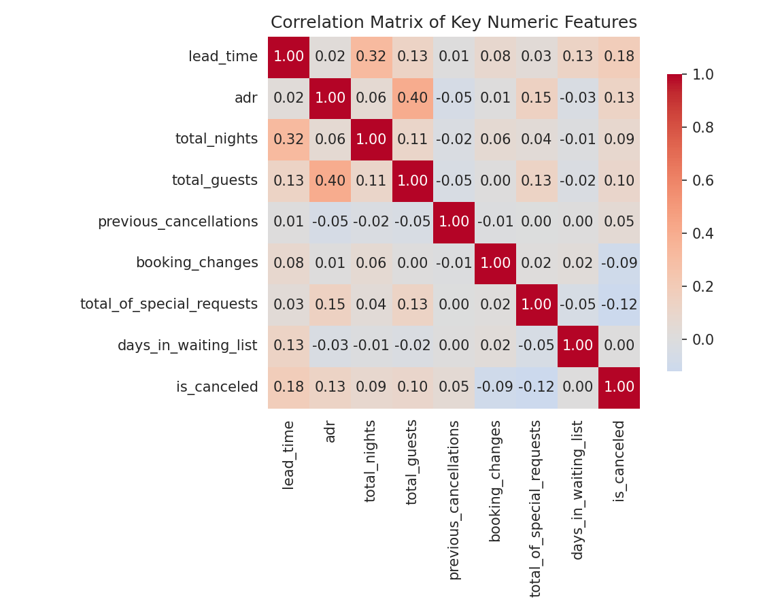
Figure 1. Correlation matrix of key booking features and cancellation (Module 1).
This module's main contribution to the rest of the project is the cleaned dataset itself, used unchanged by Modules 2, 3 and 5, and the early finding that lead time and ADR both correlate positively with cancellation - a relationship that reappears, independently derived, in Modules 3 and 5.

5. Module 2 - Time Series Forecasting
Daily arrivals of non-cancelled bookings (793 days, 2015-07-01 to 2017-08-31) were forecast using six models: two seasonal baselines, two Holt-Winters variants, a weekly SARIMA, and a SARIMAX model tuned with annual Fourier terms.
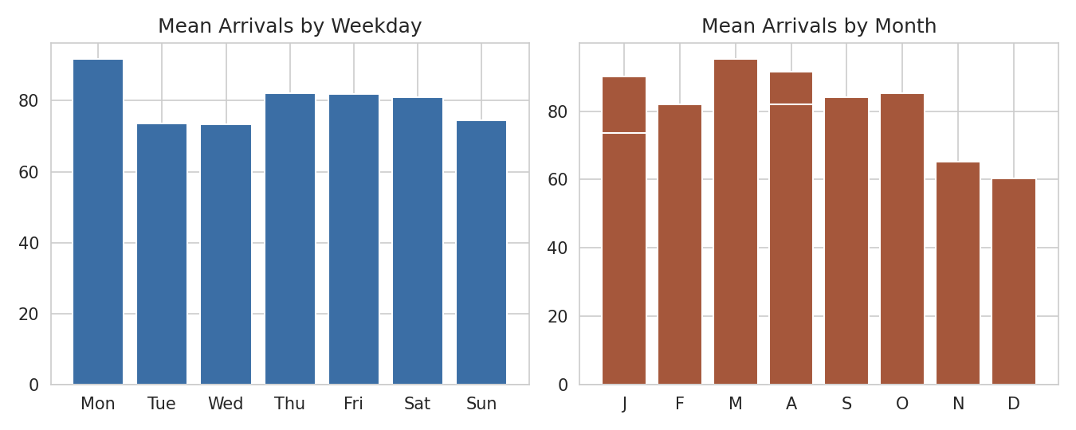
Figure 2. Mean arrivals by weekday and month (Module 2).
Model (56-day holdout) | MAE | MASE
Seasonal Avg (last 4 wks) | 11.36 | 0.62
Holt-Winters (add. season) | 11.76 | 0.64
Holt-Winters (damped trend) | 11.76 | 0.64
SARIMAX + Fourier (tuned) | 12.14 | 0.66

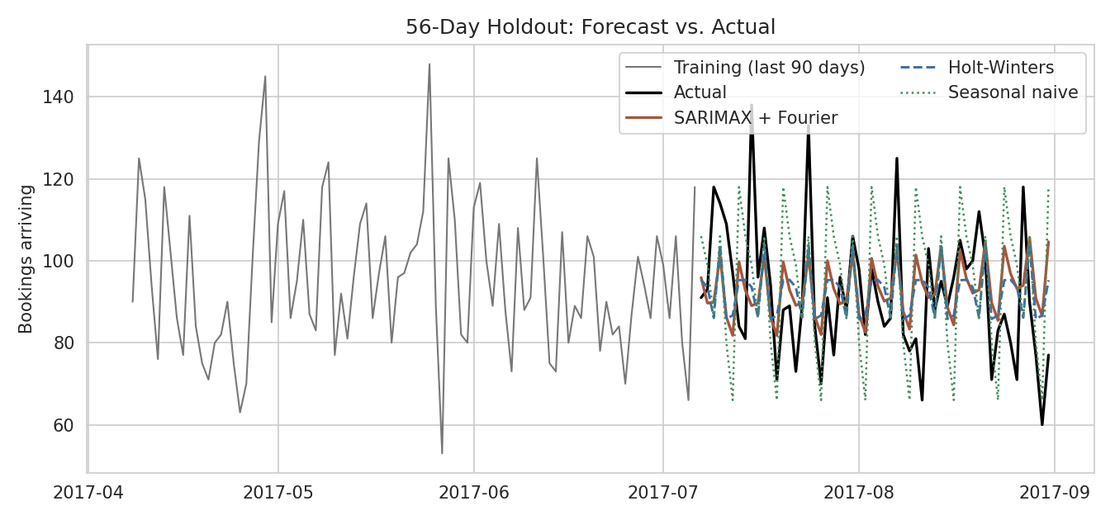
Figure 3. Forecast vs. actual arrivals on the 56-day holdout (Module 2).
Every model beat the seasonal-naive benchmark, but the holdout winner (seasonal average) and the rolling-validation winner (tuned SARIMAX, MAE 13.30) disagreed, which the module treated as a limitation of a single noisy 8-week test window rather than papering over it. Refit on all data, the tuned model forecasts average arrivals easing from 96.4 to 92.5 per day over an 8-week horizon beyond the data.

6. Module 3 - Customer Segmentation
Ten behavioural and demographic features (lead time, stay length, party size, ADR, special requests, and flags for children, repeat status, prior cancellation and booking changes) were clustered with K-means. Three clusters gave the best internal validity (silhouette 0.364), confirmed by an independent Ward hierarchical clustering that reproduced almost the same grouping (agreement 0.955).
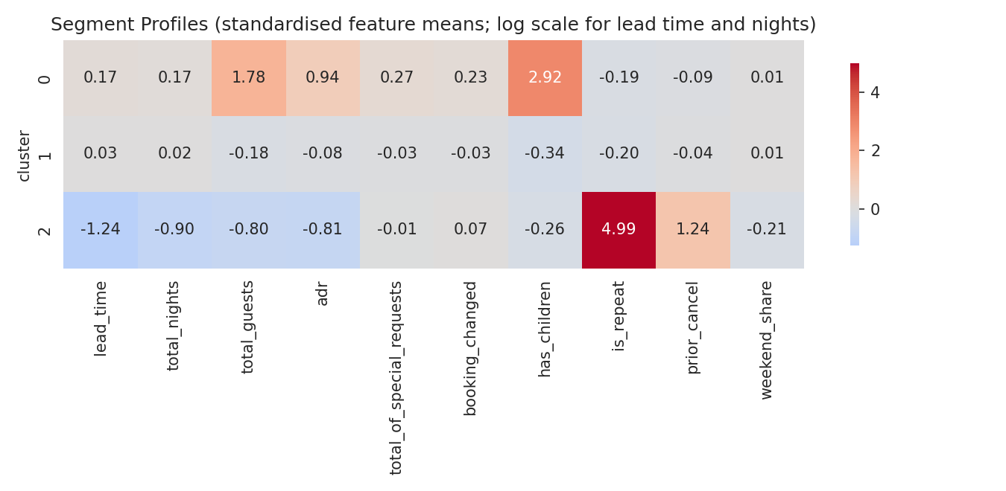
Figure 4. Standardised segment profiles (Module 3).
Segment | Share of bookings | Median ADR | Cancellation rate | Revenue share
Families | 10.4% | 149.6 | 34.6% | 14.4%
Mainstream Leisure | 85.8% | 96 | 27.6% | 83.6%
Loyal Short-Stay Regulars | 3.8% | 65 | 7.8% | 2%

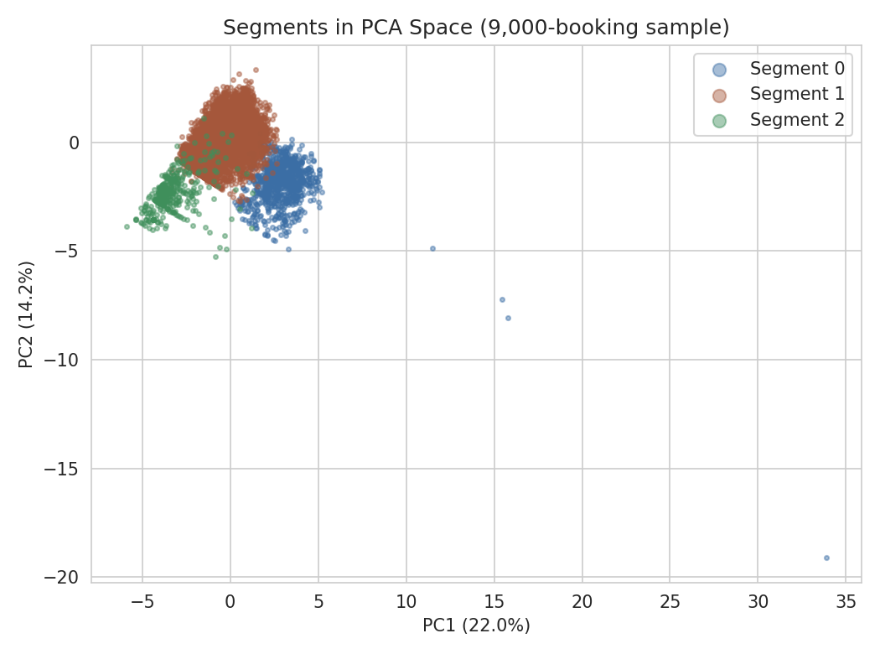
Figure 5. Segments in PCA space (Module 3).
This module's main contribution to the rest of the project is a named, quantified customer typology - Families, Mainstream Leisure, Loyal Short-Stay Regulars - that Section 9 reconnects to the seasonal patterns of Module 2 and the pricing patterns of Module 5.

7. Module 4 - Sentiment Analysis
20,491 TripAdvisor reviews were repaired (corrupted apostrophes and split negations from an already-processed source file), cleaned, and scored with five methods.
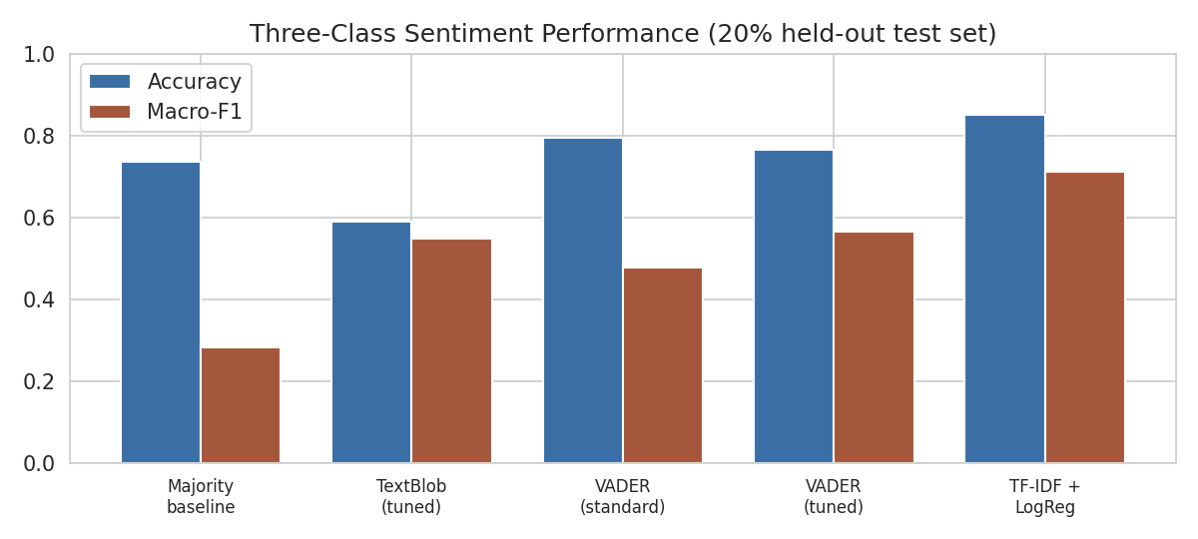
Figure 6. Sentiment method comparison on the held-out test set (Module 4).
Method | Accuracy | Macro-F1
Majority-class baseline | 0.737 | 0.283
VADER, standard cut-offs | 0.795 | 0.478
TF-IDF + Logistic Regression | 0.852 | 0.712

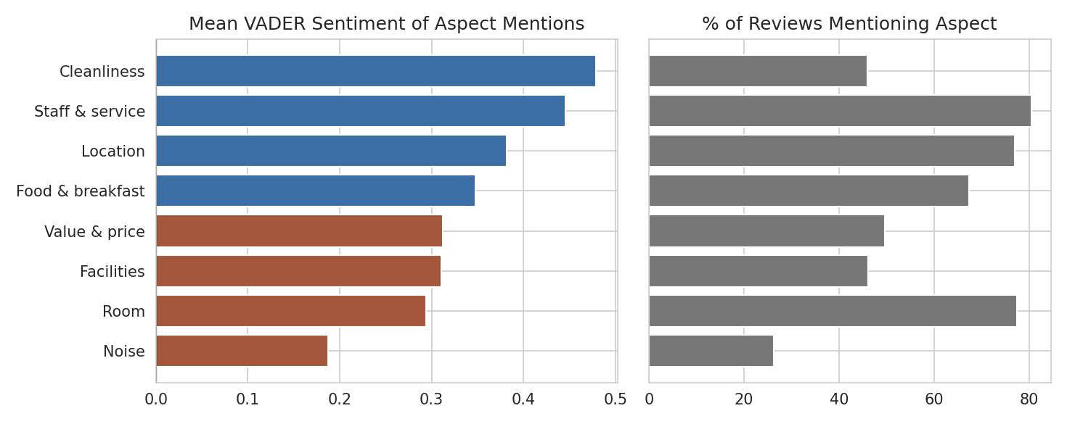
Figure 7. Aspect-based sentiment: mean score and mention rate (Module 4).
Default lexicon tools label about 92% of reviews positive against 74% by star rating, because long reviews mix praise and complaint and a single compound score saturates; clause-level scoring corrected part of this (correlation with rating rising from 0.46 to 0.58). Aspect analysis found cleanliness and staff as clear strengths and room condition and noise as the weakest aspects of guest experience - a theme that reappears in Module 5's discussion of what a hotel can defensibly charge more for.

8. Module 5 - Revenue Management and Pricing
Occupancy and RevPAR proxies were built from booking arrivals against an assumed capacity per hotel, and used in a hedonic OLS pricing model, a price-elasticity estimation exercise, and RevPAR-optimisation scenarios.
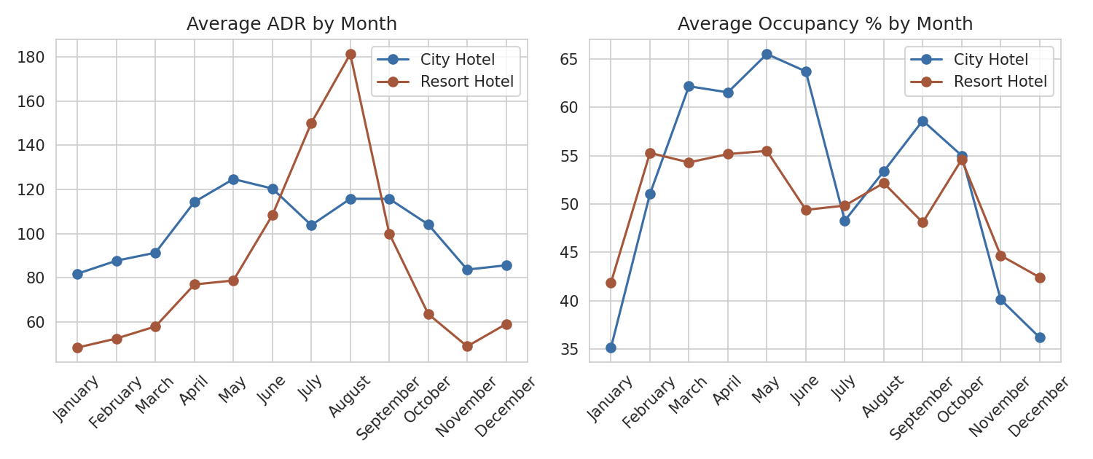
Figure 8. ADR and occupancy seasonality by hotel (Module 5).
Model | R-squared | Key finding
Hedonic ADR model | 0.431 | August prices 62.9% above January, controlling for booking characteristics
Naive price-demand elasticity | 0.153 | Coefficient 0.483 - positive, diagnosed as reverse causality, not used for pricing

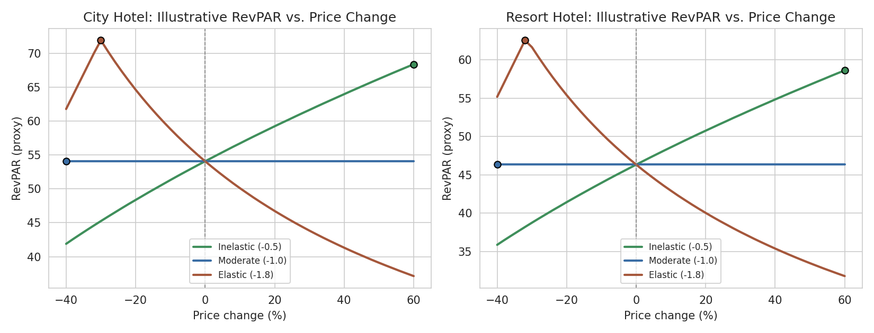
Figure 9. Illustrative RevPAR-optimisation scenarios under three assumed elasticities (Module 5).
This module's central methodological contribution - openly diagnosing why a standard elasticity regression fails on this kind of data, rather than reporting a misleading number - is one of the more advanced pieces of reasoning in the whole project, and Section 11 returns to it.

9. Analytical Synthesis: Connecting the Five Modules
The individual modules were built separately, in different weeks, using different subsets of features and, in Module 4's case, an entirely different dataset. This section deliberately looks for places where their independent findings agree, reinforce, or usefully complicate one another.

9.1 The Families segment explains the summer demand peak
Module 2 found a clear summer peak in arrivals (Figure 2); Module 5 found ADR peaks sharply in August (Resort Hotel especially, Figure 8). Checking Module 3's segments against the calendar shows why: the Families segment holds 10.4% of bookings overall but 18.3% in August - almost double its baseline share (see Figure 10). Families are, in effect, the segment driving the seasonal demand and price cycle that Modules 2 and 5 each detected independently, without either being told the segment existed.
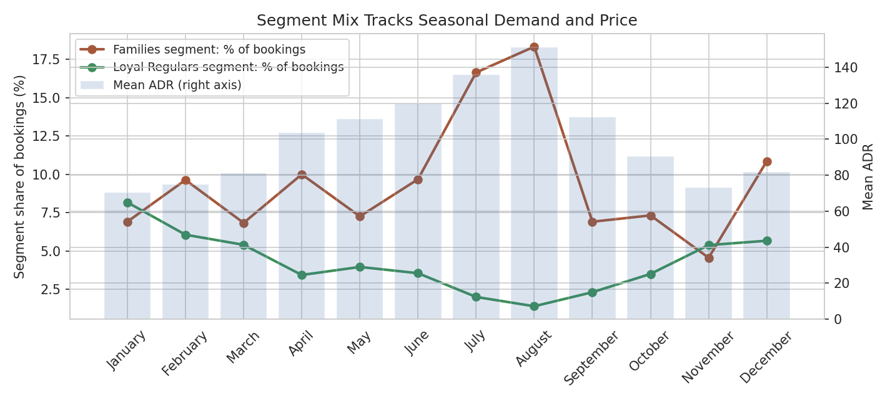
Figure 10. Families and Loyal Short-Stay Regulars segment share by month, against mean ADR (new analysis for this report).
The Loyal Short-Stay Regulars segment shows the opposite pattern: its share falls from a winter high to a low of just 1.4% in August, consistent with a corporate/local-business guest who travels least during the summer holiday period. This gives the seasonality found in Modules 2 and 5 a customer-level explanation that neither module could see on its own.

9.2 Segmentation and revenue management independently agree on cancellation-by-price risk
Module 5 found cancellation rate rising steadily from 17.4% in the cheapest ADR quintile to 34.5% in the most expensive. Module 3, built independently with a different feature set and clustering algorithm, found the Families segment - whose median ADR of 149.6 falls in that same top quintile - has a cancellation rate of 34.6%, almost exactly matching Module 5's top-quintile figure of 34.5%. Two different analyses, on two different cuts of the same data, converge on the same number. This is meaningful cross-validation: it suggests the price-cancellation relationship is a real property of the data rather than an artefact of either method, and it means Module 5's pricing recommendation (tighten cancellation policy at higher price points) and Module 3's segment strategy (flexible-change policies for Families) are really the same recommendation seen from two angles.

9.3 Sentiment themes point at the same weaknesses revenue data prices around
Module 4 found room condition and noise as the weakest-scoring guest experience aspects, even though these reviews cannot be linked to the two hotels analysed elsewhere. Module 5's hedonic model shows length of stay and party size, not room quality, driving most of the explainable price variation - meaning current pricing does not obviously discriminate by room condition. Read together, these point to an opportunity rather than a contradiction: if room condition is a widespread driver of guest dissatisfaction (Module 4) but is not currently priced as a differentiator (Module 5), then room-tier pricing informed by condition/renovation status is a lever this project's data did not have the fields to test directly, but which the combination of modules surfaces as worth testing.
This particular link is the weakest of the three in this section, precisely because the two datasets do not share hotels or guests - it is offered as a hypothesis the two analyses jointly suggest, not a finding either one proves alone.

9.4 A single, coherent operating calendar
Put together, Modules 2, 3 and 5 support one integrated seasonal operating picture: forecasted arrivals rise through spring into a summer peak (Module 2); that peak is disproportionately made up of the highest-value, highest-cancellation-risk Families segment (Module 3); and pricing already responds to this seasonally (Module 5) but weekday/weekend pricing within each season is comparatively flat (a Module 5 finding not yet acted on). This is the kind of coordinated, cross-functional view - demand, customer mix, price and satisfaction moving together - that a hotel's revenue management and guest experience teams would need to plan a season jointly rather than from separate spreadsheets.

10. Consolidated Strategic Recommendations
# | Recommendation | Modules combined
1 | Build a seasonal calendar around the Families segment: staff, price and communicate for the July-August surge as a distinct operating mode, with flexible-change policies to manage its high cancellation rate. | Forecasting + Segmentation + Revenue
2 | Tighten deposit/cancellation terms specifically at high price points, where two independent analyses agree cancellation risk is highest (roughly 34-35%). | Segmentation + Revenue
3 | Introduce or strengthen weekday/weekend pricing within each season; the data shows strong month effects but a comparatively flat weekend premium (1.5-3.6%). | Revenue
4 | Target the Loyal Short-Stay Regulars segment (corporate/local, lowest cancellation) with off-season and shoulder-season offers, since their volume is highest exactly when Families volume is lowest - a natural demand-smoothing pairing. | Segmentation + Forecasting
5 | Prioritise front-desk service standards and room-condition audits; these are the weakest-scoring guest-experience aspects and are not currently reflected in how price varies. | Sentiment + Revenue
6 | Grow the Direct booking channel, which carries the best rate at both properties in this data, ahead of intermediary-heavy channels. | Revenue
7 | Before acting on any price-elasticity number from historical data, validate it with a controlled test; this project's own elasticity regression produced an implausible result once diagnosed as reverse causality. | Revenue
8 | Re-run sentiment and segmentation on the hotel's own, linked guest and review data before deploying Section 9.3's hypothesis operationally. | Sentiment + Segmentation

11. Limitations and Critical Reflection
Limitation | Scope
Two datasets, not fully linked | Sentiment analysis cannot be tied to the specific bookings, segments or price points analysed elsewhere; Section 9.3's synthesis is explicitly flagged as a hypothesis, not a proven link
Occupancy and RevPAR are proxies | No true capacity field exists; capacity was assumed near the 99th percentile of observed daily arrivals per hotel (Module 5)
Elasticity could not be identified causally | Historical price-quantity data reflects the hotel's own revenue-management reactions to anticipated demand, not an independent demand curve (Module 5, Section 5.1 of that module)
Segmentation quality is moderate, not strong | Silhouette 0.36 sits in the 'weak structure' band of common guidance; segments are useful simplifications of gradual behavioural variation, not sharply separated populations (Module 3)
Forecasting evaluated on one 8-week window | The holdout-best and cross-validation-best models disagreed, showing single-window evaluation is not fully reliable at this data volume (Module 2)
Sentiment labels are star ratings, not human annotation | Accuracy figures measure agreement with ratings, not with independently verified sentiment (Module 4)
Two hotels, one country, 2015-2017 | All five modules share this scope; conclusions may not generalise to other markets, hotel types, or the current period
Presenting these limitations together, rather than only within each module, is itself part of the synthesis: several of them compound. For example, the moderate segmentation quality (Module 3) combined with the unlinked sentiment data (Module 4) means Section 9.3's room-condition hypothesis carries two layers of uncertainty and should be treated as a research question, not a ready-to-implement finding.

12. Conclusion
This project took one real hospitality dataset through a complete analytics lifecycle - cleaning, forecasting, segmentation, and pricing - and paired it with an independent sentiment analysis of public hotel reviews. Each module stands on its own evidence: a cleaned base of 87,221 bookings; a forecasting model that beats naive baselines but is honest about the limits of an 8-week evaluation window; a three-segment guest typology confirmed by two different clustering algorithms; a sentiment pipeline that diagnoses why simple lexicon tools mislead on long, mixed reviews; and a pricing analysis that correctly recognises when its own regression cannot be trusted for a business decision.
The more important result, and the one specific to this final report, is that these independently built analyses corroborate each other without having been designed to: the segment that clustering identified as high-value and high-risk is the same segment driving the seasonal peak that forecasting found and the seasonal price premium that the revenue model found, and two unrelated calculations of cancellation-by-price risk land on the same number. That kind of convergence across independently built models is, in applied data science, a stronger form of evidence than any single model's internal metrics, and it is the clearest demonstration in this report of how forecasting, segmentation, sentiment analysis and revenue management genuinely function as one connected system in hospitality decision-making rather than four separate exercises.

References
Antonio, N., de Almeida, A., & Nunes, L. (2019). Hotel booking demand datasets. Data in Brief, 22, 41-49.
Hutto, C. J., & Gilbert, E. (2014). VADER: A parsimonious rule-based model for sentiment analysis of social media text. Proceedings of ICWSM-14.
Hyndman, R. J., & Athanasopoulos, G. (2021). Forecasting: Principles and Practice (3rd ed.). OTexts.
Kaufman, L., & Rousseeuw, P. J. (1990). Finding Groups in Data: An Introduction to Cluster Analysis. Wiley.
Kimes, S. E. (2011). Customer-based revenue management: Setting rates based on customer response to price. Cornell Hospitality Report, 11(2).
Pedregosa, F., et al. (2011). Scikit-learn: Machine learning in Python. Journal of Machine Learning Research, 12, 2825-2830.
Seabold, S., & Perktold, J. (2010). statsmodels: Econometric and statistical modeling with Python. Proceedings of the 9th Python in Science Conference.
TripAdvisor Hotel Reviews dataset (public CSV, 20,491 reviews), accessed via a public GitHub repository.

